gioperation you may lose your files.

22.Create an empty directory ‘Assignments’ & cd to ‘Assignments’.

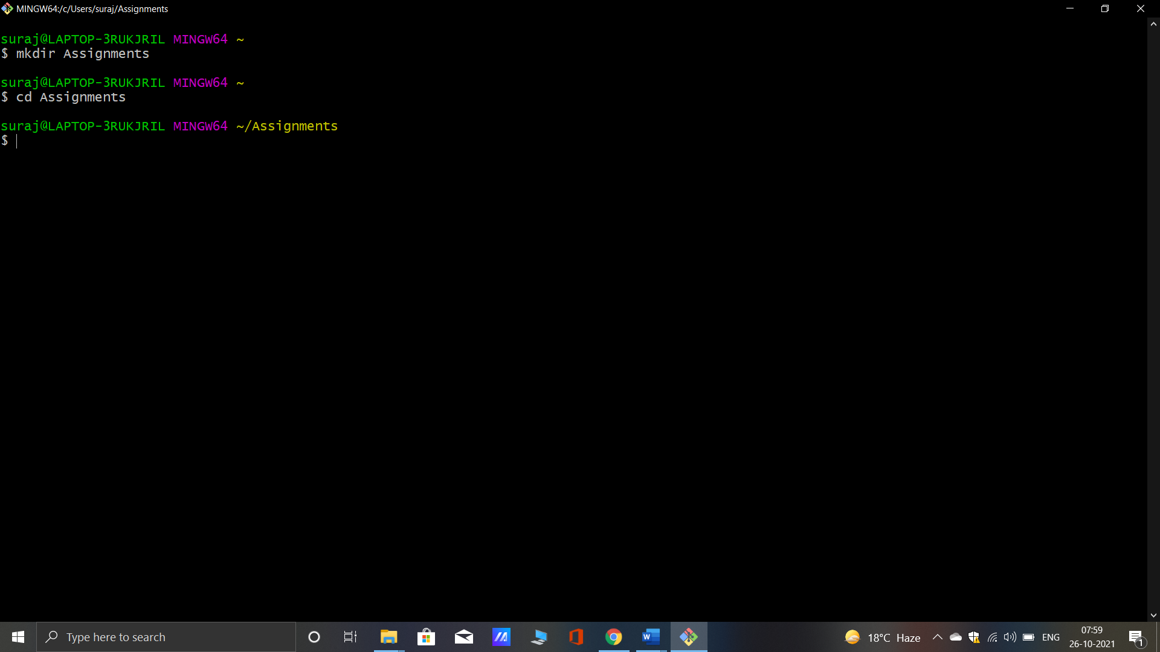

23.Create a file README.txt inside ‘Assignments’ & write few lines about the contents of ‘Assignments’ folder.

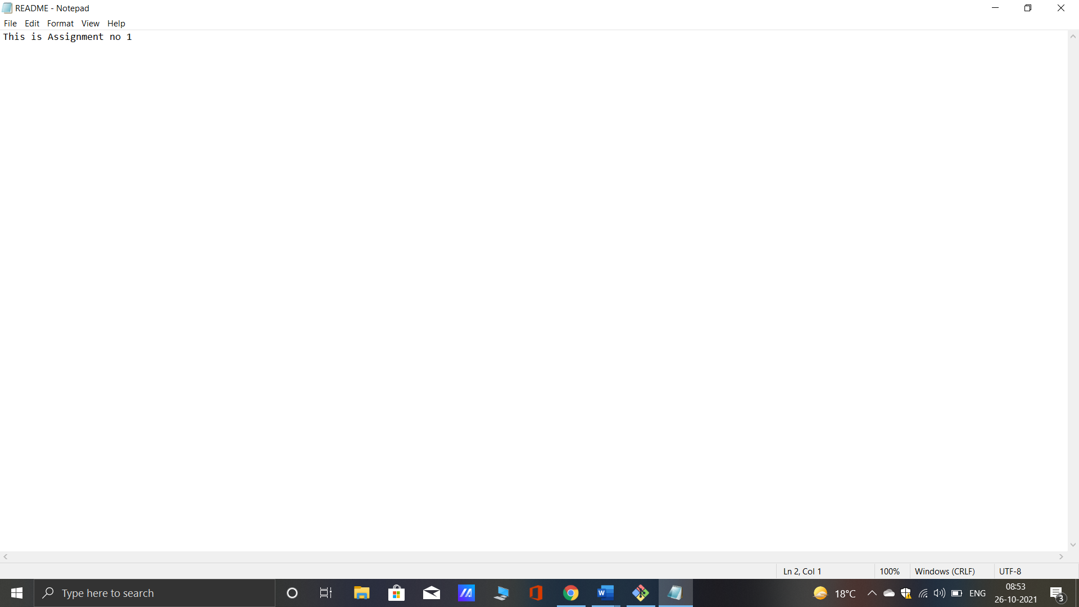24. Commit README.txt file.

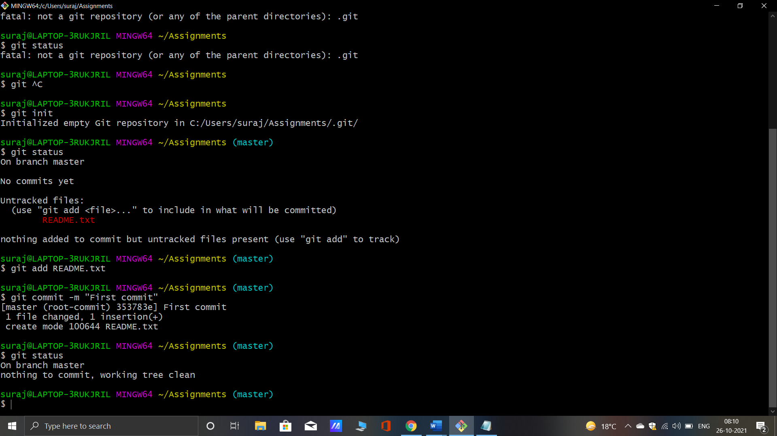

25.Now create a new branch ‘html-assignments’

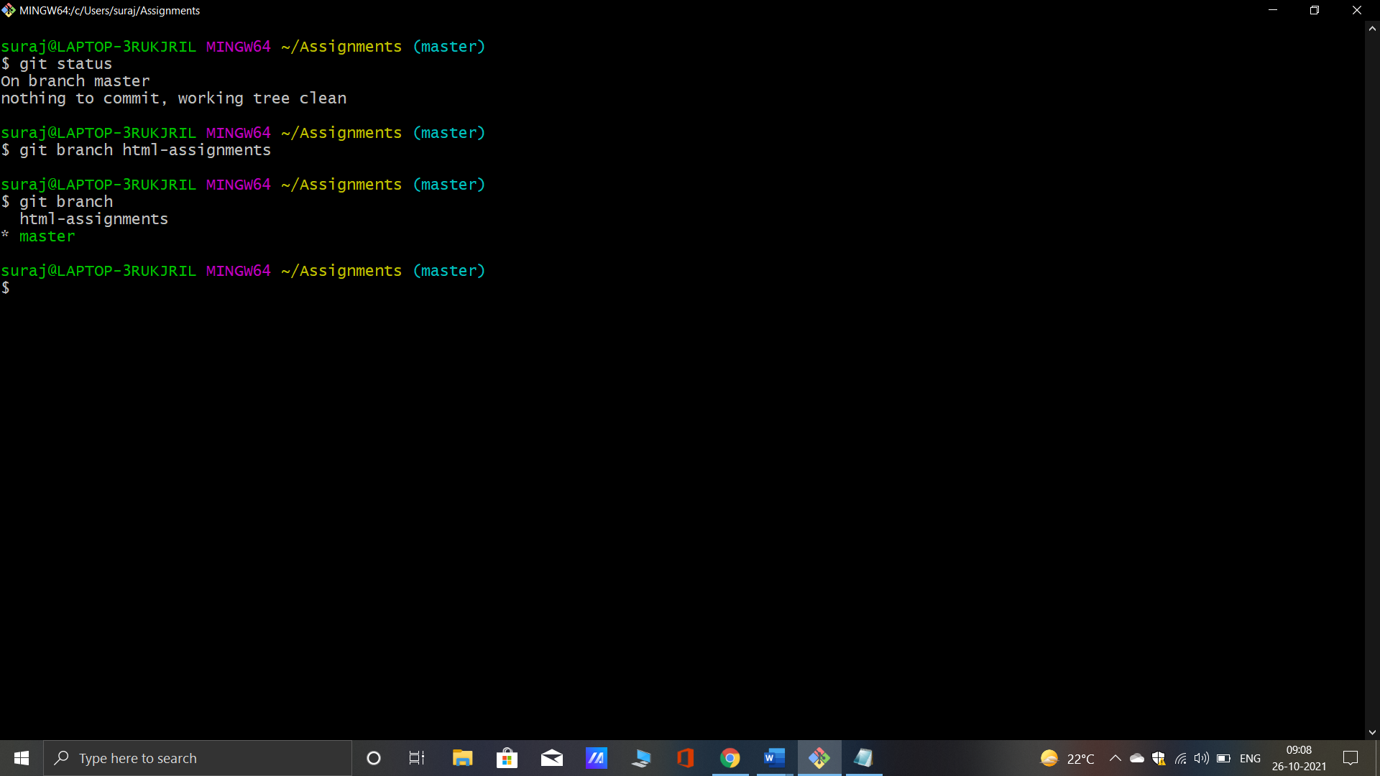

26.Switch to ‘html-assignments’ branch.

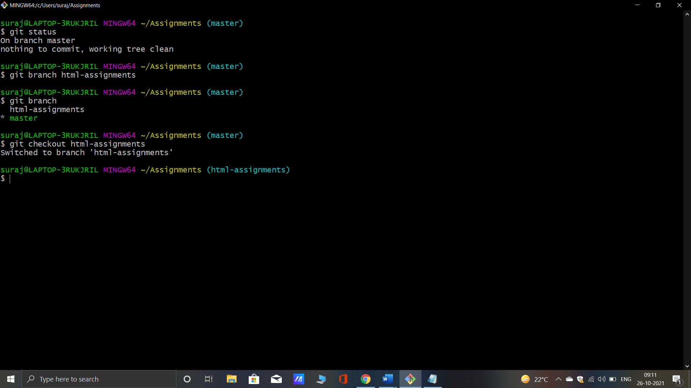

27.Copy all HTML assignments inside ‘Assignments’ folder.

28.Commit HTML assignments into ‘html-assignments’ branch.

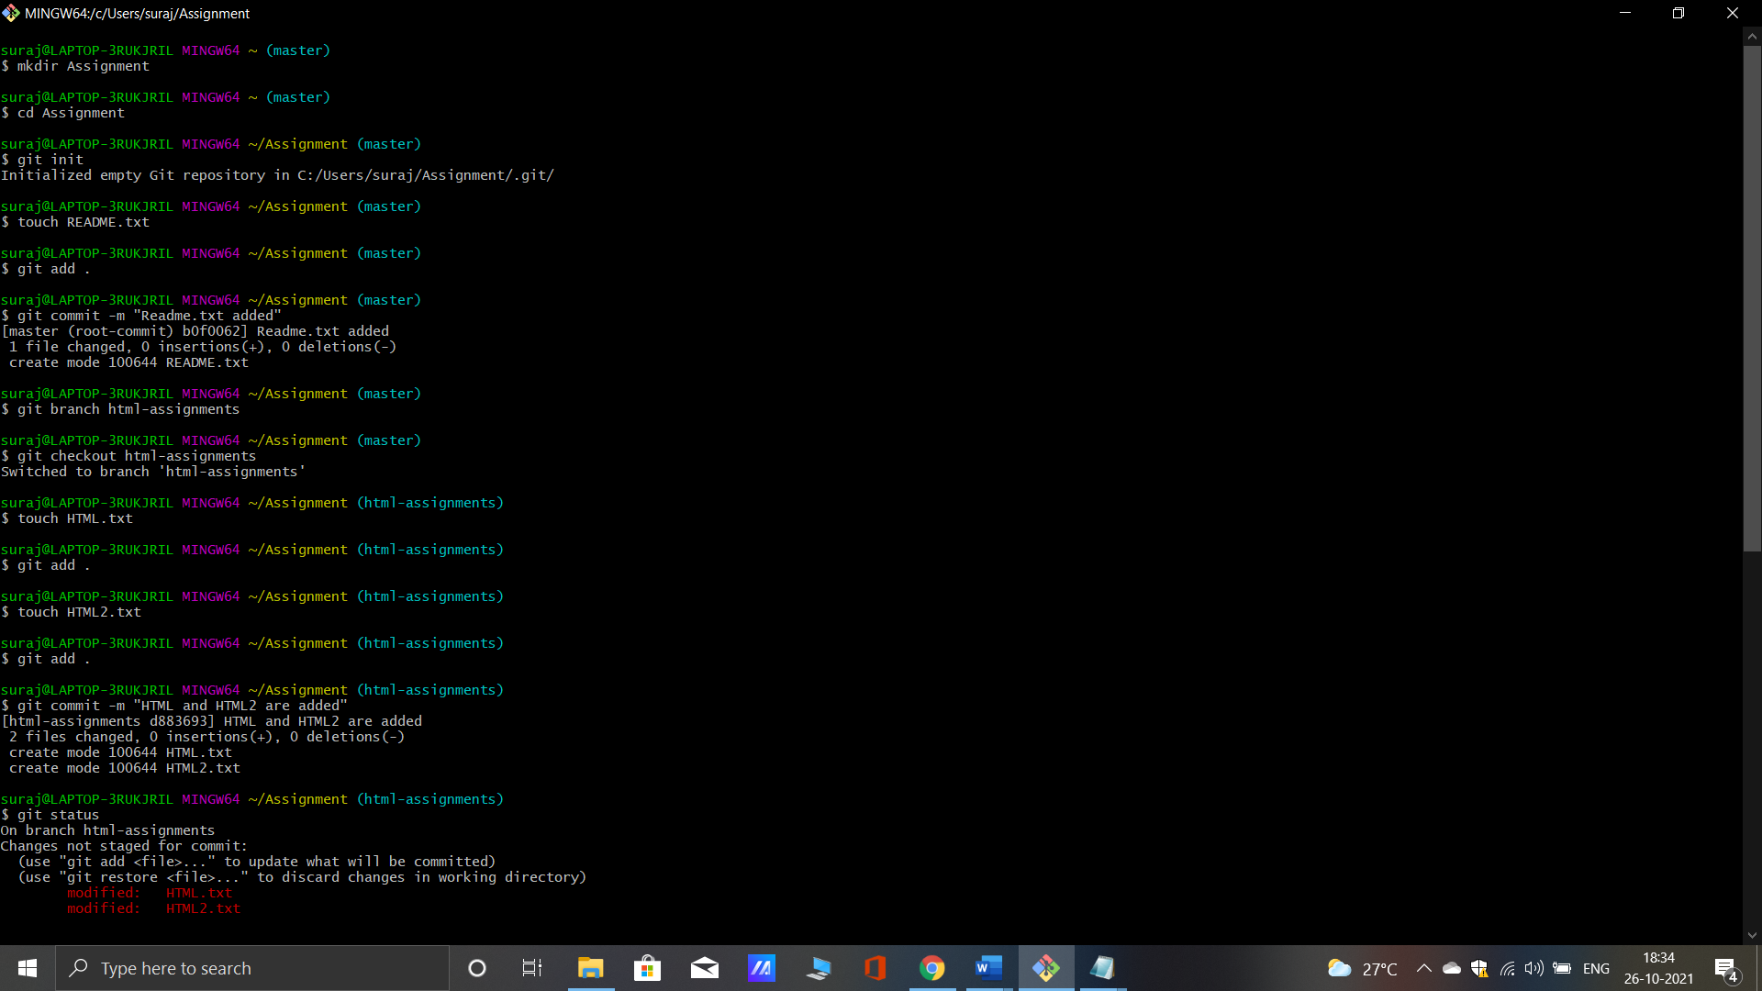

29. Make minor changes into few files belonging to ‘html-assignments’ branch.

30.Commit those changed files.



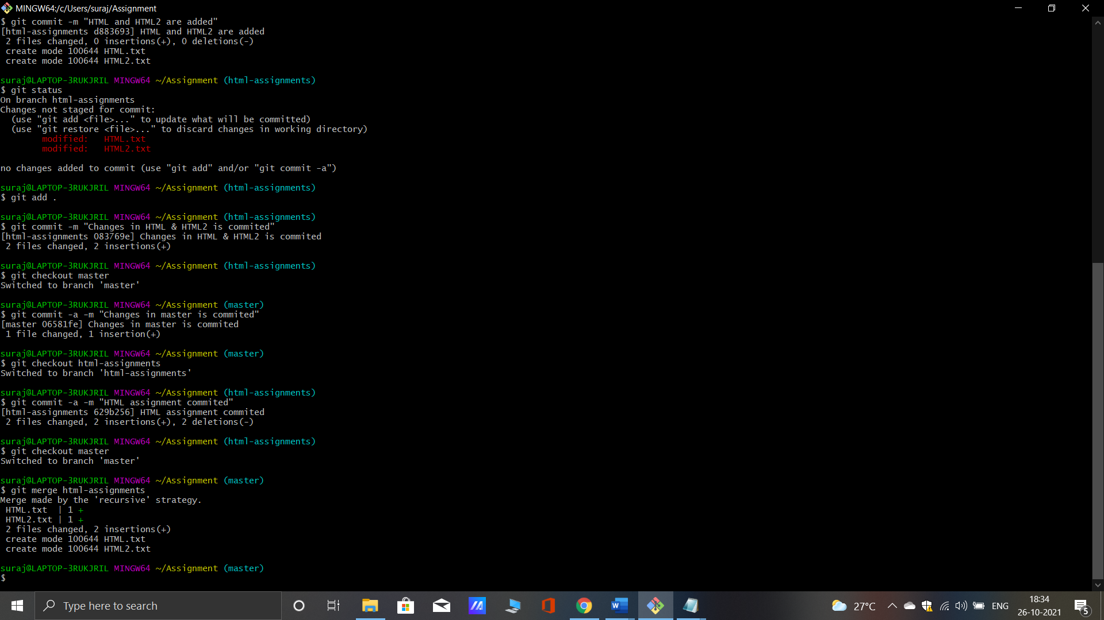

31. Switch to master branch.

32.Make minor changes into README.txt file & commit those changes into master.



33. Again switch to ‘html-assignments’ branch.

34.Make minor changes into few files belonging to ‘html-assignments’ branch.

35.Commit those changes.



36. Switch to master.

37.Merge ‘html-assignments’ branch into master. Confirm all html assignments are shown in master.



38. Finally delete the ‘html-assignments’ branch.

